42U ENCLOSURE 19" CABINET 800X600 FLOOR STANDING DATA RACK - VALUCAB
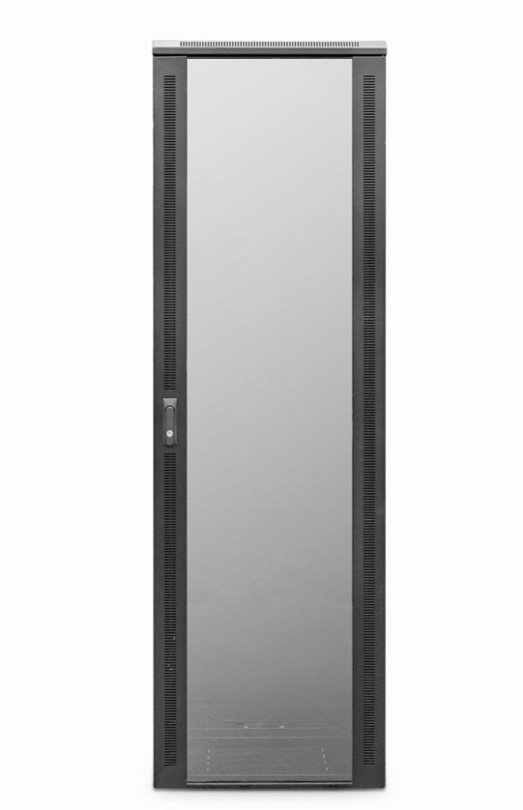

DESCRIPTION
The LMS Data ValuCab Enterprise edition cabinets come in a variety of heights, widths and depths so will be ideal for almost all professional applications including that of data centres, IT departments, PBX exchanges in both enterprise, SME and public sector installations.
UK assembled means quality assurance is built in. Together with a superior manufacturing process, fully adjustable front and rear 19-inch uprights, choice of cable entry points, left-right hinged safety glass door and ease of post installation is assured thanks to removable side panels and rear door.
Bundled with castors, jacking feet and M6 captive screw assembly kit, the ValuCab also enjoys the vast amount of LMS Data accessories for the Enterprise edition series.

SPECIFICATIONS
42U high 800W 600D
• ETSI 19” front/rear profiles, adjustable
• Lockable vented glass door, reversible
• Removable side panels, rear lockable door
• Integral Front Cable Management fitted
• Ideal for SME, IT Rooms, PBX & Broadcast
• Fitted castors and jacking feet (4))
• UK Assembled and quality assured

TECHNICAL INFO
SKU/MPN: CAB-FE-42U-86NA
EAN: 8400800034342
Weight: 90kg
Dimensions: 800 (width) x600((depth) x2050mm (height)

FILES

Datasheet - CAB-FE-42U-86NA.pdf

